Insert School Logo

Semester One

Examination 2020

Question/Answer booklet

MATHEMATICS
METHODS UNIT 1

Section Two:
Calculator–assumed

Student Name: _____________________________________

Teacher’s Name: _____________________________________

Time allowed for this section
Reading time before commencing work: ten minutes
Working time for paper: one hundred minutes

Material required/recommended for this section

To be provided by the supervisor
This Question/Answer booklet
Formula Sheet (retained from Section One)

To be provided by the candidate
Standard items: pens (blue/black preferred), pencils (including coloured), sharpener, correction tape/fluid, erasers, ruler, highlighters

Special Items: drawing instruments, templates, notes on two unfolded sheets of A4 paper, and up to three calculators approved for use in the WACE examinations.

Important note to candidates
No other items may be taken into the examination room. It is your responsibility to ensure that you do not have any unauthorised notes or other items of a non–personal nature in the examination room. If you have any unauthorised material with you, hand it to the supervisor before reading any further.

Structure of this paper

 | Number of questions available | Number of questions to be attempted | Working time (minutes) | Marks available | Percentage of exam
Section One  Calculator—free | 8 | 8 | 50 | 52 | 35
Section Two  Calculator—assumed | 17 | 17 | 100 | 98 | 65
 |  |  |  | 150 | 100

Instructions to candidates

- The rules for the conduct of Western Australian external examinations are detailed in the
Year 12 Information Handbook 2020. Sitting this examination implies that you agree to abide by these rules.

- Answer the questions according to the following instructions.

Show all your working clearly. Your working should be in sufficient detail to allow your
answers to be checked readily and for marks to be awarded for reasoning. Incorrect answers given without supporting reasoning cannot be allocated any marks. For any question or part question worth more than two marks, valid working or justification is required to receive full marks. If you repeat an answer to any question, ensure that you cancel the answer you do not wish to have marked.

It is recommended that you do not use pencil, except in diagrams.

- You must be careful to confine your responses to the specific questions asked and to follow any instructions that are specific to a particular question.

- Spare pages are included at the end of this booklet. They can be used for planning your responses and/or as additional space if required to continue an answer.
- Planning: If you use the spare pages for planning, indicate this clearly at the top of the page.
- Continuing an answer: If you need to use the space to continue an answer, indicate in the original answer space where the answer is continued, i.e. give the page number. Fill in the number of the question that you are continuing to answer at the top of the page.

- The Formula Sheet is not handed in with your Question/Answer Booklet.

Section Two: Calculator–assumed 65% (98 marks)

This section has seventeen (17) questions. Attempt all questions. Write your answers in the spaces
provided.

Spare pages are included at the end of this booklet. They can be used for planning your responses
and/or as additional space if required to continue an answer.

- Planning: If you use the spare pages for planning, indicate this clearly at the top of the page.
- Continuing an answer: If you need to use the space to continue an answer, indicate in the original answer space where the answer is continued, i.e. give the page number. Fill in the number of the question(s) that you are continuing to answer at the top of the page.

Working time: 100 minutes

Question 9 (6 marks)

(a) A diameter of a circle has endpoints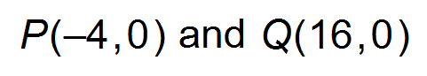. Determine the y – intercepts of the circle. (3 marks)

(b) The circumference of a circle (C) is directly proportional to the radius (r).

(i) State the exact constant of proportionality. (1 mark)

(ii) Draw a graph on the axes below to show the relationship between C and r.
Label the axes and all critical features. (2 marks)
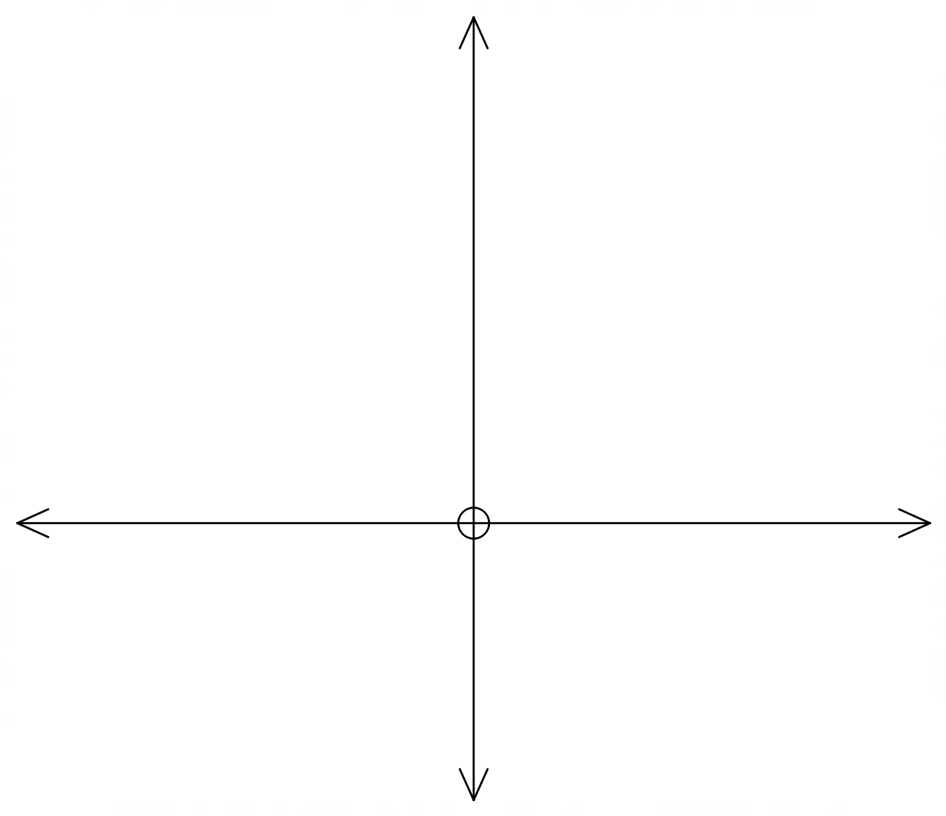

Question 10 (6 marks)

The radius of a circle, with centre O, is 2 units. R(a, b) and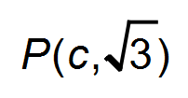are points on the circle.
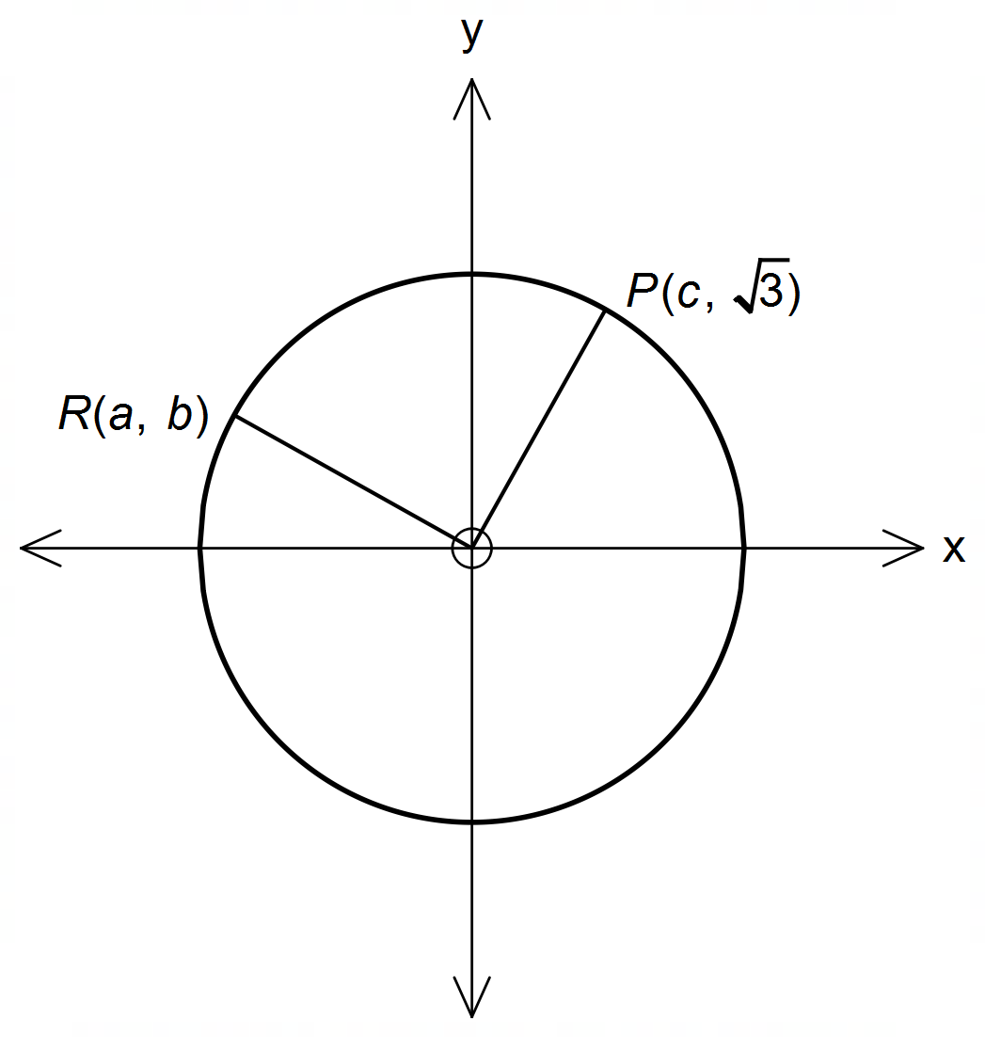Let the angle between the positive x – axis and the line OP be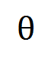and the angle ROP is 90°.

Determine the value(s) of:

(a) c. (1 mark)

(b) 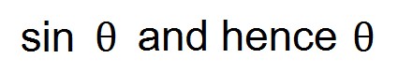. (2 marks)

(c) 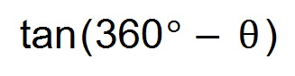. (1 mark)

(d) a and b. (2 marks)

Question 11 (6 marks)

If it rains on a given day, the probability that it rains the next day is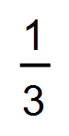. If it does not rain on a given day, the probability that it rains the next day is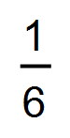. The probability that it will rain tomorrow is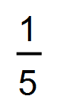.

(a) Draw a tree diagram to show all the probabilities and outcomes. (3 marks)

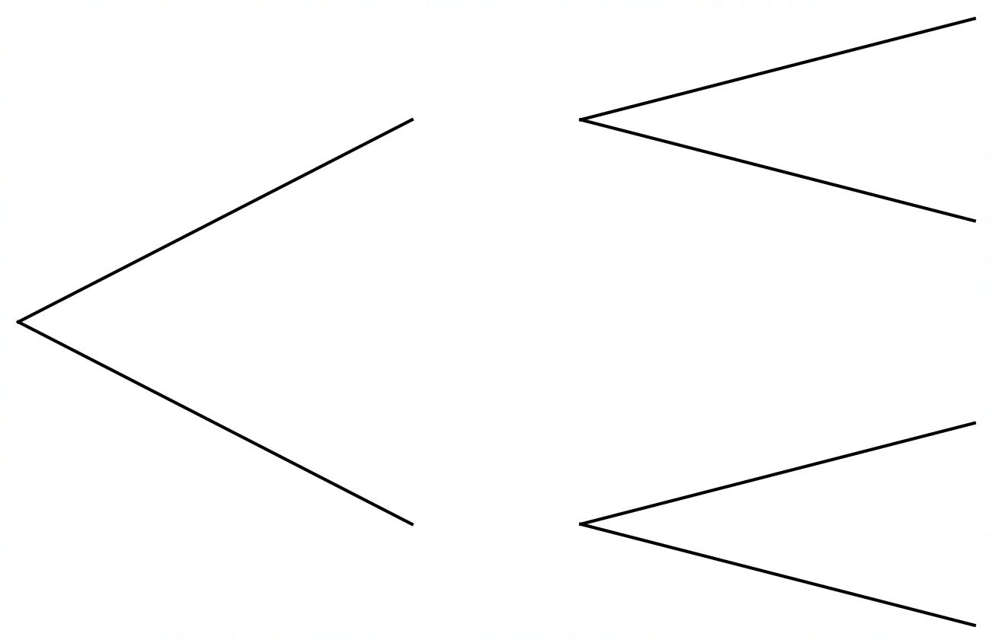

(b) Determine the probability that:

(i) it will rain the day after tomorrow. (1 mark)

(ii) it will rain tomorrow and the next day. (1 mark)

(iii) there will be no rain the next day, given that it rains tomorrow. (1 mark)

Question 12 (5 marks)

(a) Line q is perpendicular to the line with the equation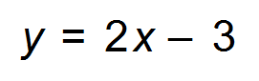. Line q has the same
x – intercept as the line with the equation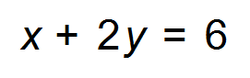. Determine the equation of line q.
(3 marks)

(b) For what value(s) of k is the line through the points (3, 2k +1) and (8, 4k – 5) parallel to the x – axis. (2 marks)

Question 13 (4 marks)

It is known that events A and B are independent,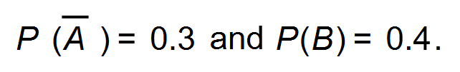
Use this information and the probability rules to complete the two way table.

 | A | 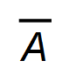 | Total
B
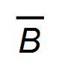
Total |  |  | 50

Question 14 (7 marks)

A pendulum is 90 cm long and swings through an angle of 0.6 radians. The extreme positions of the pendulum are indicated by the points A and B in the diagram.

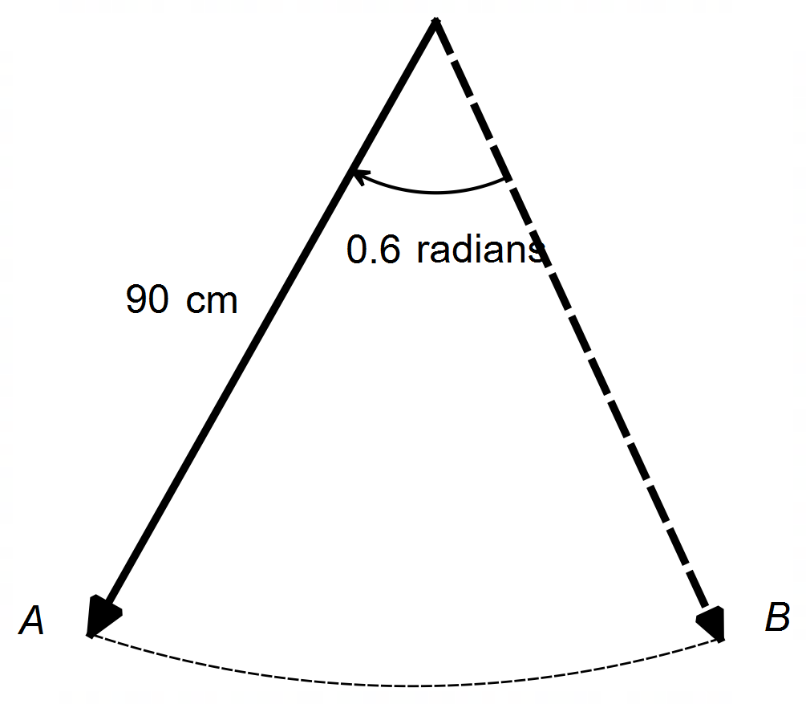

(a) Explain why 0.6 radians is equivalent to 34.38°. (1 mark)

(b) Find the length of the arc AB. (2 marks)

(c) Find the straight line distance between the extreme positions of the pendulum
(i.e. the distance from A to B.). Round to 3 decimal places. (2 marks)

(d) Find the area of the sector swept out by the pendulum. (2 marks)

Question 15 (10 marks)

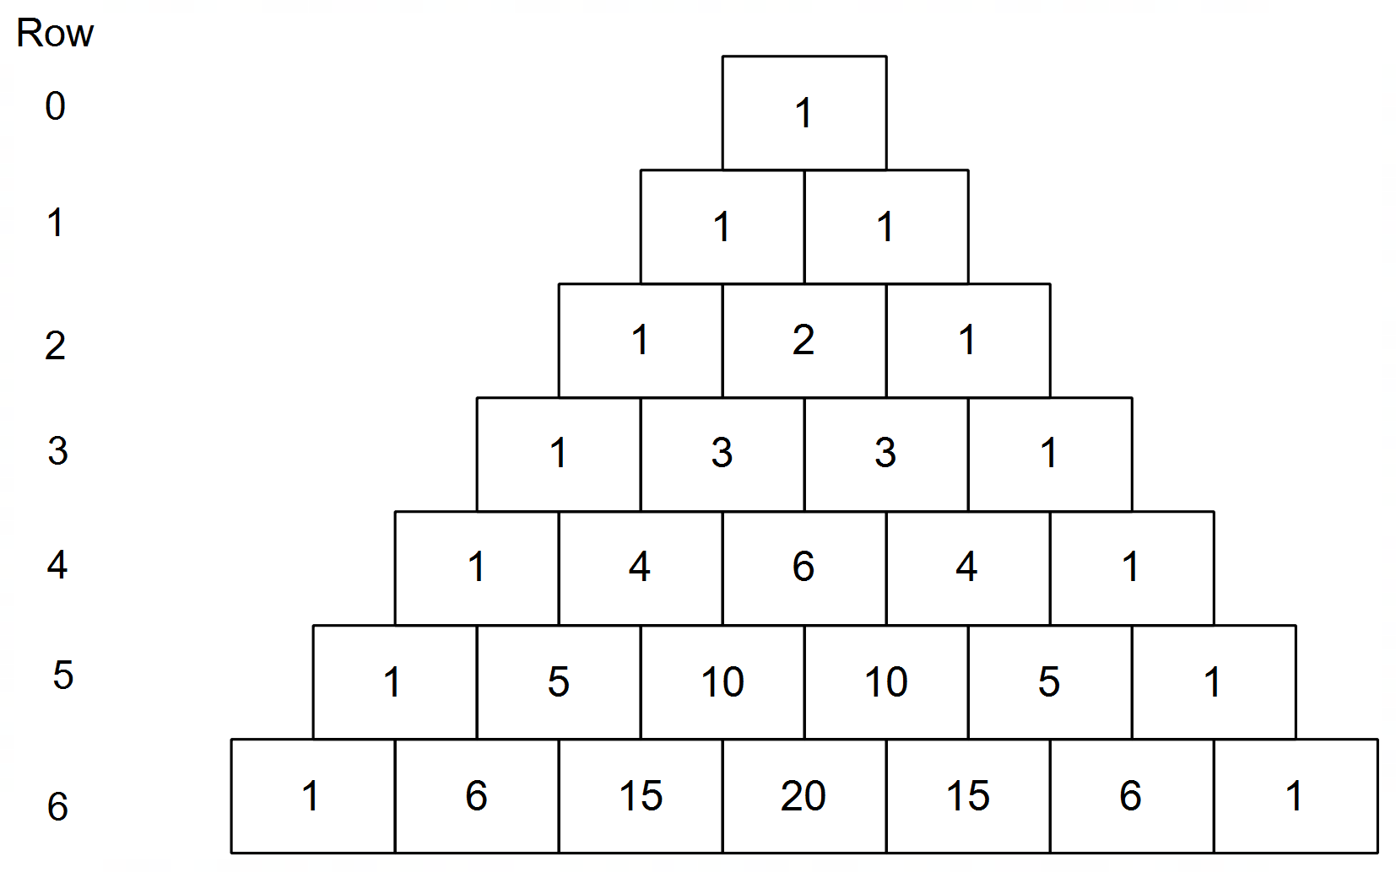Given below is Pascal’s triangle.

(a) (i) Use the definition of ^{n}C_{r} to show that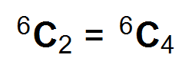. (2 marks)

(ii) Explain how this symmetry relates to Pascal’s triangle. (1 mark)

(b) Consider the diagonal row in Pascal’s triangle 1, 3, 6, 10 …. These are the triangular numbers and have the formula 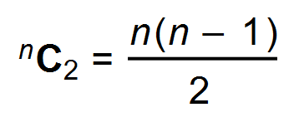, where n is the row number.
(i) Use an example of a triangular number to show how this formula works. (1 mark)

(ii) Use the formula to find the triangular number in row 21. (1 mark)

(c) Use Pascal’s triangle to find the coefficient of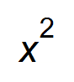in the expansion of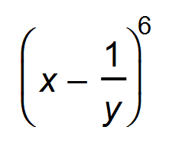. (1 mark)

(Question 15 continued)

(d) Use Pascal’s triangle to expand, and hence show that the value of 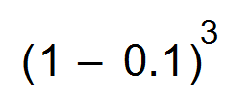 = 0.729.
(2 marks)

(e) The Save our Planet group is designing a website. The template they have chosen has places for 3 large photos and 19 smaller photos. There are 6 large photos they can choose from and 21 smaller photos. Given these choices, how many different possible combinations of photos are possible? (2 marks)

Question 16 (3 marks)
Consider the quadratic equation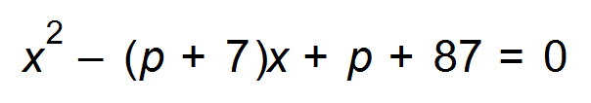where p is a negative real number.
Solve for x given that the equation has one distinct real solution. (3 marks)

Question 17 (5 marks)

In the diagram, square PQRS has side length 2 cm. Points M and N are midpoints of SR and RQ respectively.
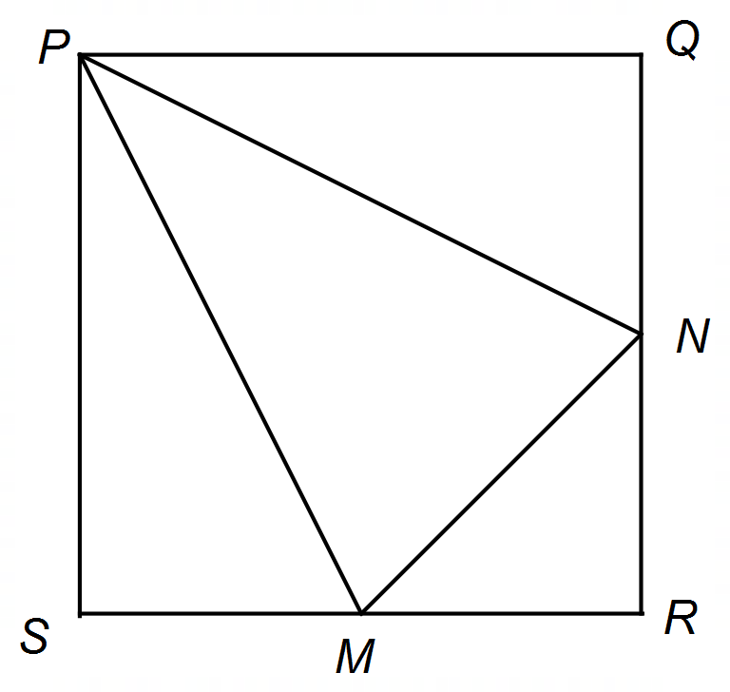

(a) Show that the angle MPN = 0.6435 radians. (3 marks)

(b) Hence, or otherwise determine the area of $∆$ MPN. (2 marks)

Question 18 (6 marks)

(a) Lisa rolls two 6-sided dice. Let E be the event that the total number of dots on the dice is 10.
Let F be the event that at least one die is a three.

(i) Determine the probabilities for events E and F. (2 marks)

(ii) Are E and F mutually exclusive? Justify your answer. (2 marks)

(b) It is known that G and H are independent events, such that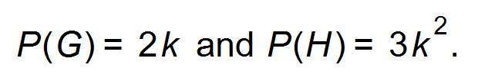 Calculate the value of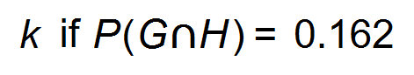. (2 marks)

Question 19 (8 marks)

400 Year 11 students meet to solve problems regarding ways to stop plastic entering the ocean.
270 students volunteer to walk along popular beaches and pick up all litter (event L).
300 students volunteer to go to cafes to advocate that no plastic straws be used (event S).
50 students volunteer at the plastic recycling plant (event R).

(a) Find the values of a, b, c and d in the Venn diagram below. (4 marks)

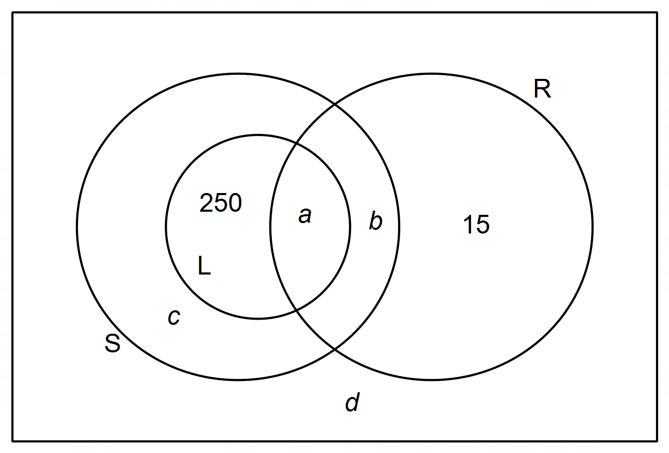

(b) Calculate the probability that a student chosen at random will:

(i) volunteer to advocate against using plastic straws only. (1 mark)

(ii) volunteer to advocate against using plastic straws but not work at the recycling plant.
(1 mark)

(iii) volunteer to pick up litter or work in the recycling plant given they will be doing at least one of the three activities. (2 marks)

Question 20 (10 marks)

The manager of a private bus company has worked out a model for the relation between the number of passengers carried each week and the profit, (in tens of $), the company makes. If n is the number of passengers carried, the profit is given by 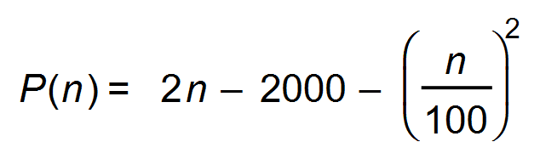.
(a) Can the relation P(n) be described as a function. Justify your answer. (1 mark)

(b) Describe the concavity of the relation. (1 mark)

(c) Determine the minimum number of passengers needed per week for the company to make a profit. (1 mark)

(d) Determine the maximum profit made according to this model and how many passengers are carried during the week to achieve this profit. (2 marks)

(e) (i) Determine the simplified expression for P(n + 1) − P(n), and explain what this
expression represents. (3 marks)

(ii) How many passengers would the bus company carry in a week if the profit
made by one extra passenger was 50 cents? (2 marks)

Question 21 (3 marks)

It is given that two quantities, p and r, are indirectly proportional such that p varies inversely to the cube root of r. If r increases by 300%, determine the effect on p.

Question 22 (4 marks)

(a) State the equation of the graph below: (2 marks)
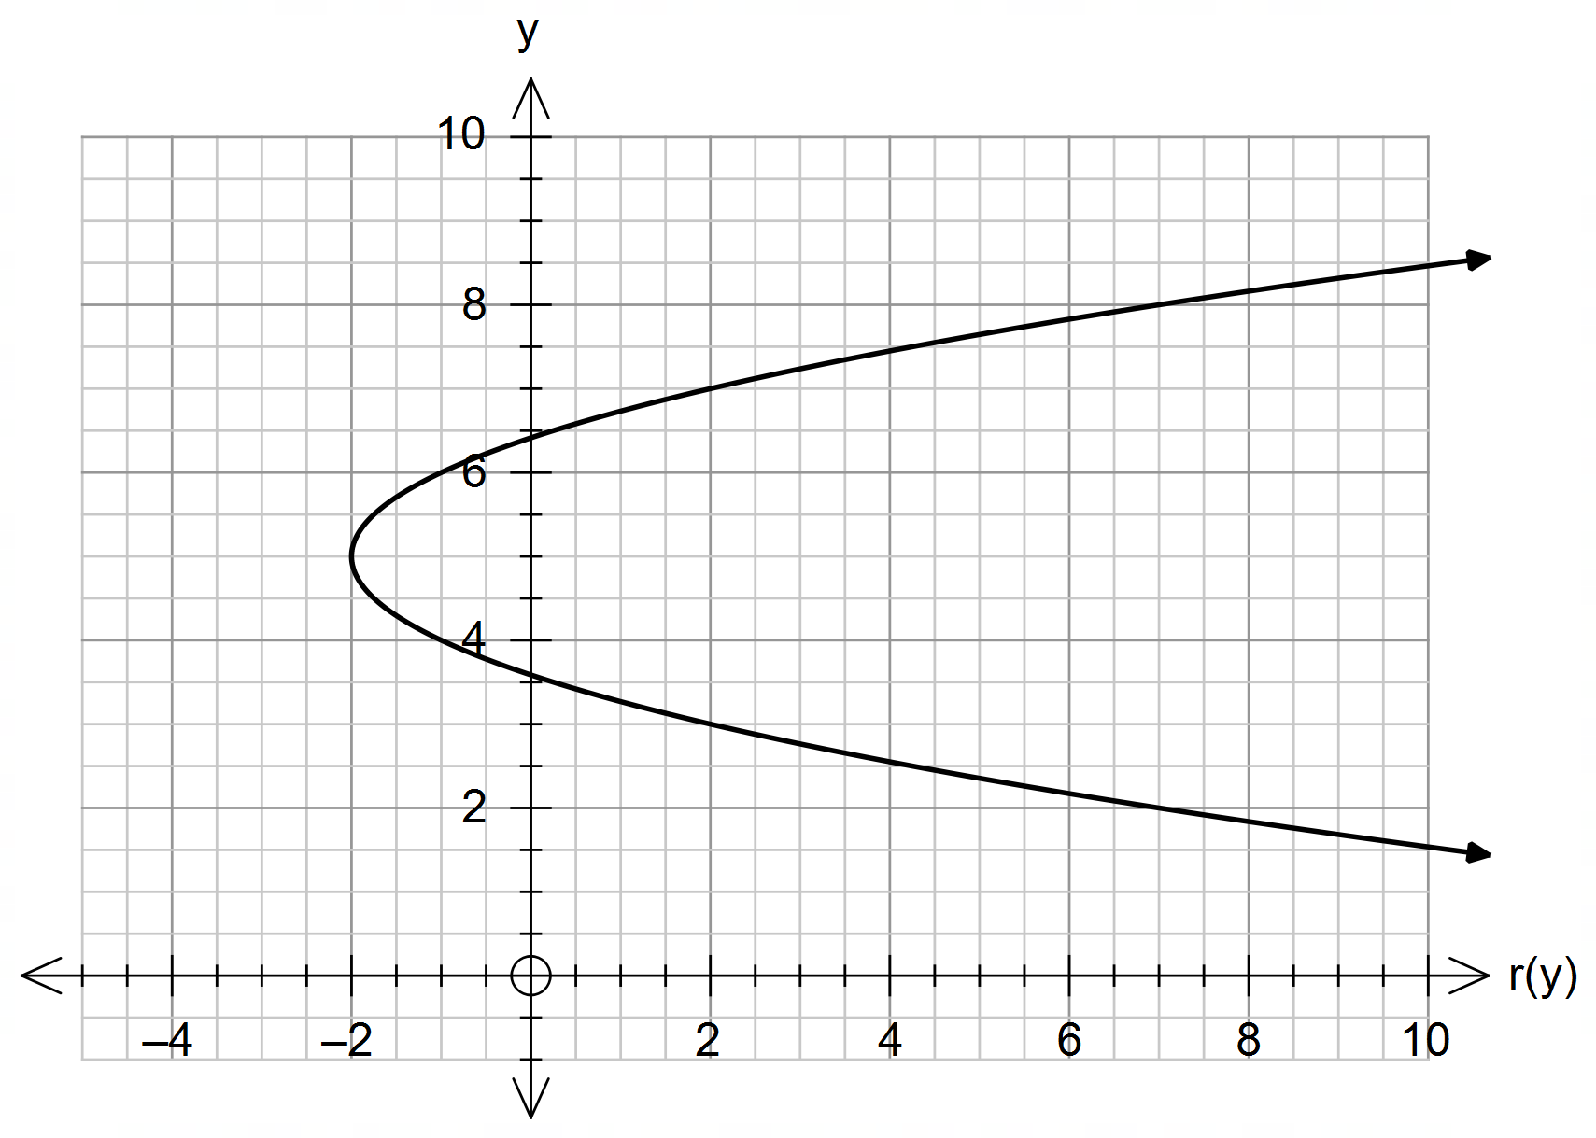

(b) Apply the vertical line test to the graph of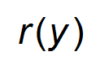and explain its significance. (2 marks)

Question 23 (4 marks)

Three aircraft, marked, Z, U and W, are flying in a triangular formation at an air show, at the same speed and altitude. Aircraft Z is 8.25 m from aircraft U which is 6.5 m from aircraft W.
The angle WZU formed is 48°.

Determine how far aircraft W is flying from aircraft Z?

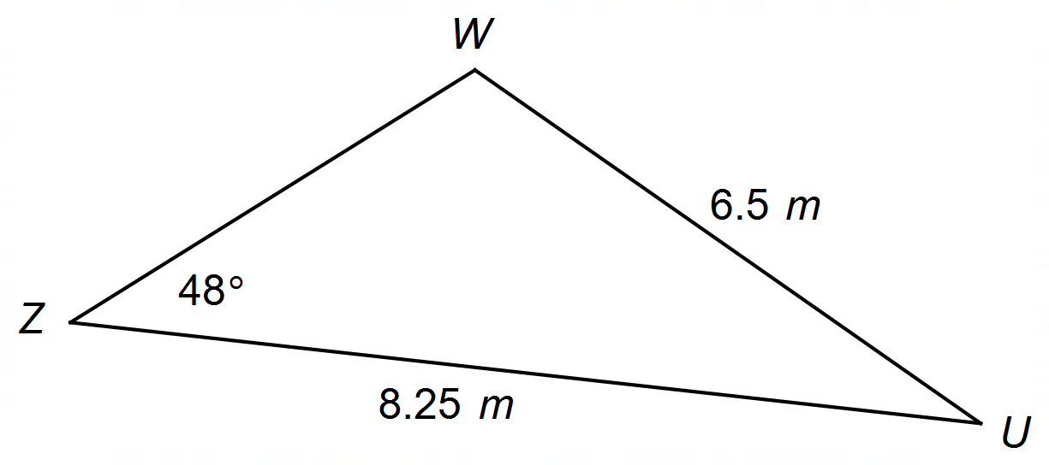

Question 24 (7 marks)

A medical trial into the effectiveness of a vegan diet was carried out over a period of a year.
120 females and 90 males took part in the trial. Out of these people, 50 females’ and 30 males’ health indicators responded positively to the diet.

(a) Complete the table below with the given information. (2 marks)
 | Female | Male | Total
Positive
Negative or no response
Total

(b) Find the probability that the vegan diet gives:

(i) a positive result for females. (1 mark)

(ii) a negative or no result for males or females. (1 mark)

(c) Was the vegan diet’s success independent of gender? Show your reasoning. (3 marks)

Question 25 (4 marks)

(a) Determine the angle of inclination (correct to two decimal places) of the straight line passing through the points (2,1 ) and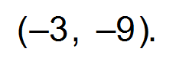 (2 marks)

(b) The graph of the function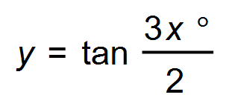 for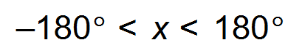is shown below.
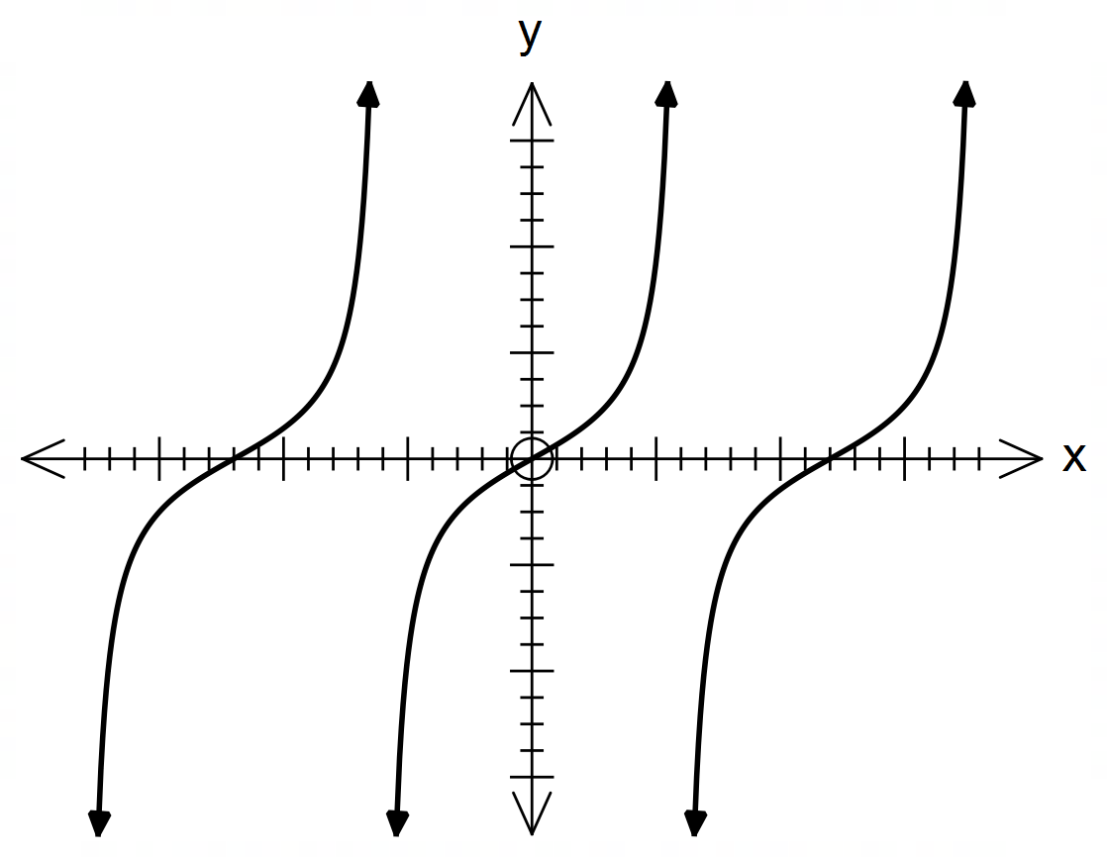

(i) State the period of the function. (1 mark)

(ii) State the domain of the function. (1 mark)

End of Questions
Additional working space

Question number(s): ……………………

Additional working space

Question number(s): ……………………

